Design and implement a network service that reliably handles concurrent client connections while ensuring graceful termination in response to external signals (e.g., SIGTERM, SIGINT). The service must maintain data consistency and avoid resource leaks throughout its lifecycle.

#include <iostream>

#include <cstring>

#include <cstdlib>

#include <unistd.h>

#include <arpa/inet.h>

#include <pthread.h>

#include <csignal>

#include <vector>

#include <mutex>

#include <algorithm>

std::vector<int> clients;

std::mutex clients_mutex;

int server_socket;

bool shutdown_requested = false;

void* handle_client(void* arg) {

int client_socket = *(int*)arg;

delete (int*)arg;

char buffer[1024];

while (true) {

ssize_t bytes_received = recv(client_socket, buffer, sizeof(buffer) - 1, 0);

if (bytes_received <= 0) break;

buffer[bytes_received] = '\0';

std::cout << "Received: " << buffer << std::endl;

if (send(client_socket, buffer, bytes_received, 0) == -1) {

std::cerr << "Failed to send data to client." << std::endl;

break;

}

}

std::cout << "Closing connection." << std::endl;

close(client_socket);

std::lock_guard<std::mutex> lock(clients_mutex);

clients.erase(std::remove(clients.begin(), clients.end(), client_socket), clients.end());

return nullptr;

}

void signal_handler(int signum) {

std::cout << "Signal " << signum << " received, shutting down." << std::endl;

shutdown_requested = true;

close(server_socket);

}

int main() {

struct sockaddr_in server_addr;

struct sockaddr_in client_addr;

socklen_t client_len = sizeof(client_addr);

signal(SIGTERM, signal_handler);

signal(SIGINT, signal_handler);

server_socket = socket(AF_INET, SOCK_STREAM, 0);

if (server_socket == -1) {

std::cerr << "Failed to create socket." << std::endl;

return EXIT_FAILURE;

}

server_addr.sin_family = AF_INET;

server_addr.sin_addr.s_addr = INADDR_ANY;

server_addr.sin_port = htons(12345);

if (bind(server_socket, (struct sockaddr*)&server_addr, sizeof(server_addr)) == -1) {

std::cerr << "Failed to bind socket." << std::endl;

close(server_socket);

return EXIT_FAILURE;

}

if (listen(server_socket, 5) == -1) {

std::cerr << "Failed to listen on socket." << std::endl;

close(server_socket);

return EXIT_FAILURE;

}

std::cout << "Server started on port 12345" << std::endl;

while (!shutdown_requested) {

int* client_socket = new int;

*client_socket = accept(server_socket, (struct sockaddr*)&client_addr, &client_len);

if (*client_socket == -1) {

if (shutdown_requested) break;

std::cerr << "Failed to accept connection." << std::endl;

delete client_socket;

continue;

}

std::cout << "Accepted connection from " << inet_ntoa(client_addr.sin_addr) << std::endl;

pthread_t client_thread;

if (pthread_create(&client_thread, nullptr, handle_client, client_socket) != 0) {

std::cerr << "Failed to create thread." << std::endl;

close(*client_socket);

delete client_socket;

continue;

}

{

std::lock_guard<std::mutex> lock(clients_mutex);

clients.push_back(*client_socket);

}

pthread_detach(client_thread);

}

{

std::lock_guard<std::mutex> lock(clients_mutex);

for (int client_socket : clients) {

close(client_socket);

}

clients.clear();

}

std::cout << "Server shut down." << std::endl;

return EXIT_SUCCESS;

}

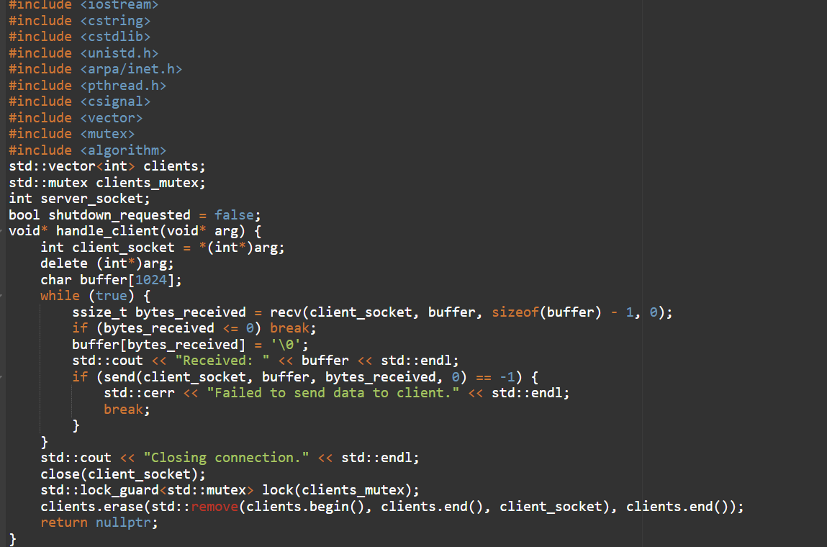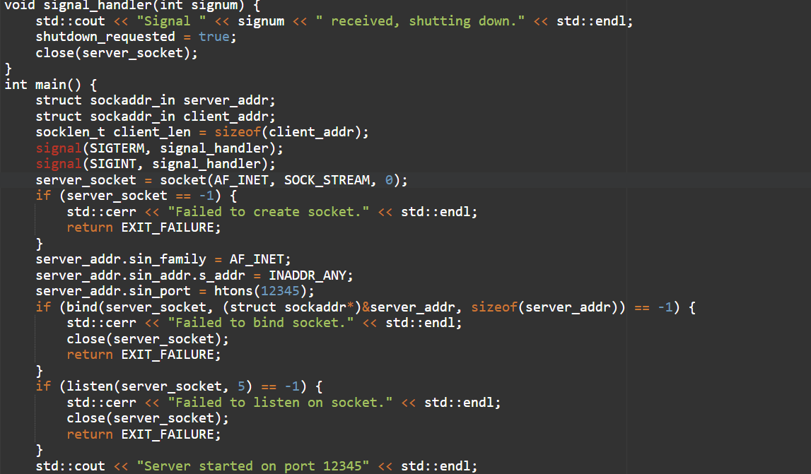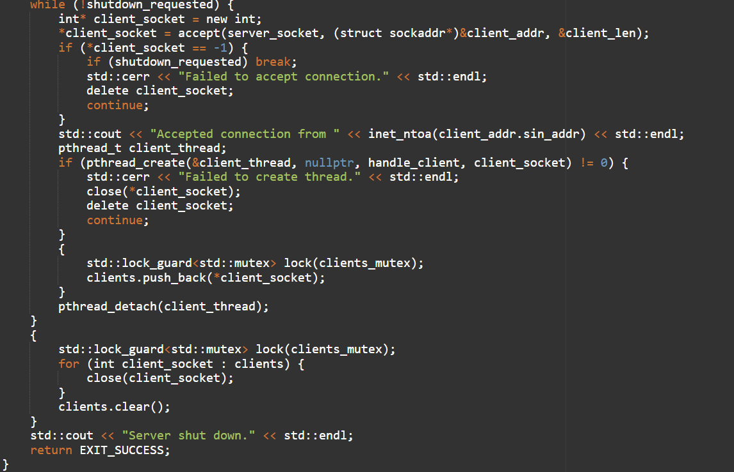

Example 1:

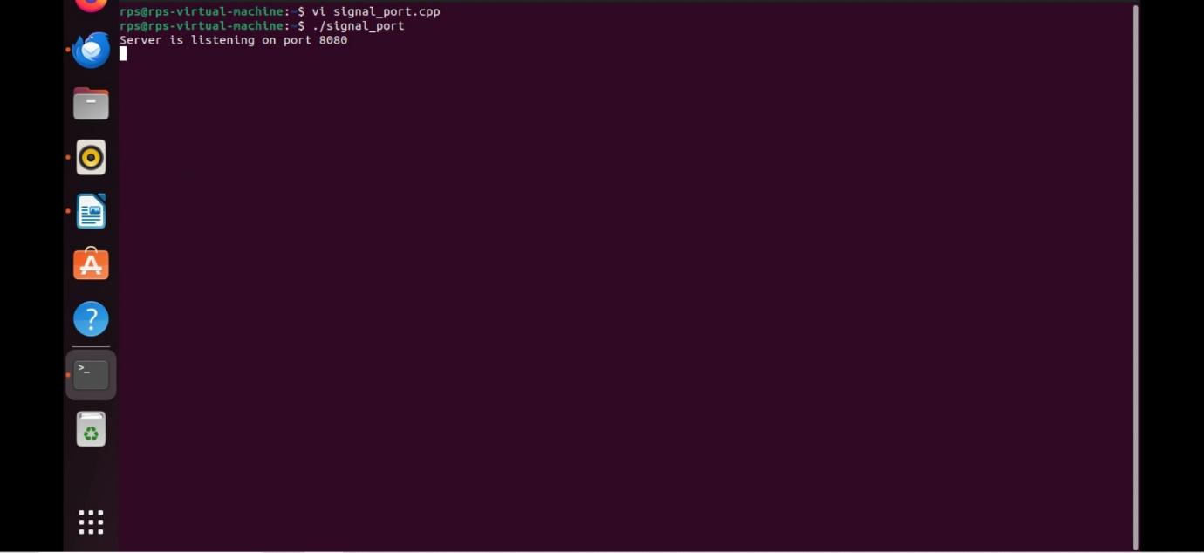

Example 2:

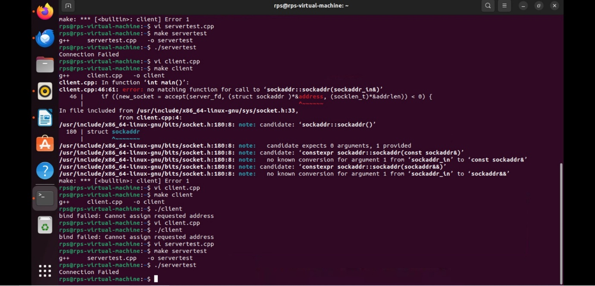

Example 3:

